*Rock the Recession* by Jonathan Slain and Paul Belair

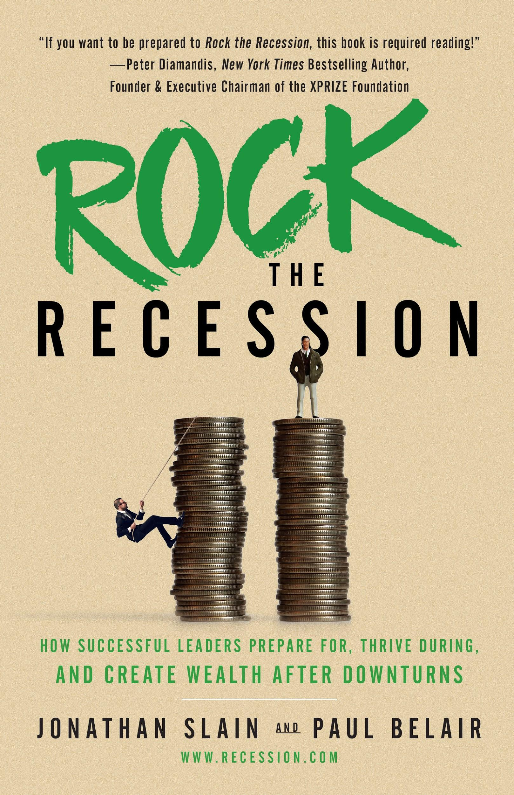

**1. Business owners don’t have to be afraid of recessions. With proper planning and awareness (and Rock the Recession’s Gearbox model) recessions can mean company growth rather than destruction.** Very few companies proactively contemplate how they might make it through a recession. Even fewer have a written recession plan, which is crucial. Jonathan and Paul give you a Recession Gearbox Model with four gears (Assess, Tune, Race, and Accelerate) to provide a roadmap to not just survive the next recession, but thrive, based on where your company is right now.

**2. Recessions are opportunities - the only problem is they don’t happen very often.** You have to plan for it now. It sounds strange, but with foresight and knowledge of your own business, recessions can mean a fantastic opportunity to buy competitors, bring new customers into your business, stock up on cheap assets, acquire disruptive tech, and hire A+ employees. You just have to know when to pounce.

**3. There’s such a thing as a non-economic recession. What would you do if your top clients left?** Remember, losing one big client can put your company in a recession. That is why it’s so important to be vigilant—even obsessive compulsive—about your largest customers. You need to be having open and honest conversations with your key customers, your top 20 percent (who often make up 50 to 80 percent of your revenue). But shouldn’t you treat all your customers equally? The authors put it bluntly: *no!*

**4. You may have to pull the Emergency Brake to save your business -- and there’s one emergency step you should consider doing right now.** You’ve got a great strategy outlined that you can implement during any downturn. But what if your plan hits a pothole? Jonathan and Paul provide an Emergency Brake plan with 4 tiered budget cuts to execute when things go haywire. Consider making tier one cuts NOW, even if you don’t need to: cut 10% of your overhead (cancel journal subscriptions, sublease some office space out, take your own trash out instead of janitorial services) and put it in the bank.

[*Rock the Recession*](https://geni.us/rocktherecession) *on Amazon / Release Date: September 17th, 2019 / Rock Publishing*